# Section 3.5: Derivatives of Trigonometric Functions

One of the most important types of motion in physics is simple harmonic motion, which is associated with such systems as an object with a mass oscillating on a spring. Being able to calculate the derivatives of the sine and cosine functions will enable us to find the velocity and acceleration of simple harmonic motion.

## Derivatives of the Sine and Cosine Functions

**The Derivatives of $\sin{x}$ and $\cos{x}$**

The derivative of the sine function is the cosine and the derivative of the cosine function is the negative sine.

$\frac{d}{dx}\left(\sin{x}\right)=\cos{x}$

$\frac{d}{dx}\left(\cos{x}\right)=-sin{x}$

The figure below shows the relationship between the graph of $f\left(x\right)=\sin{x}$ and its derivative $f^{'}\left(x\right)=\cos{x}$. Notice that at the points where $f\left(x\right)=\sin{x}$ has a horizontal tangent, its derivative $f^{'}\left(x\right)=\cos{x}$ takes on the value zero. We also see that where $f\left(x\right)=\sin{x}$ is increasing, $f^{'}\left(x\right)=\cos{x}>0$ and where $\left(x\right)=\sin{x}$ is decreasing, $f^{'}\left(x\right)=\cos{x}<0$.

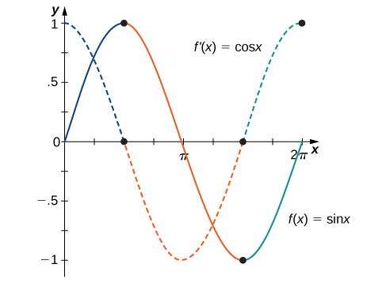

Similar observations can be made with the graph of $f\left(x\right)=\cos{x}$ and its derivative $f^{'}\left(x\right)=-sin{x}$.

Media: Watch this [video](https://youtu.be/NIh5E7jtp5k) example on trigonometric derivatives with a product rule.

Media: Watch this [video](https://youtu.be/2EeuWJuCjeQ) example on trigonometric derivatives with a quotient rule.

Examples

1. Find the derivative of each of the following.
$f\left(x\right)=5x^{3}\sin{x}$

$g\left(x\right)=\frac{\cos{x}}{4x^{2}}$

2. A particle moves along a coordinate axis in such a way that its position at time $t$ is given by $s\left(t\right)=2\sin{t}-t$ for $0≤t≤2π$. At what times is the particle at rest?

## Derivatives of Other Trigonometric Functions

Since the remaining four trigonometric functions may be expressed as quotients involving since, cosine, or both, the quotient rule can be used to find formulas for their derivatives.

**Derivatives of $\tan{x},\cot{x},\sec{x},$ and $\csc{x}$**

The derivatives of the remaining trigonometric functions are as follows:

$\frac{d}{dx}\left(\tan{x}\right)=\sec^{2} x$

$\frac{d}{dx}\left(\cot{x}\right)={-csc}^{2} x$

$\frac{d}{dx}\left(\sec{x}\right)=\sec{x}\tan{x}$

$\frac{d}{dx}\left(\csc{x}\right)=-\csc{x}\cot{x}$

Media: Watch this [video](https://youtu.be/PEqCa0U77mc) example on finding derivatives of other trigonometric functions.

Examples

1. Find the derivative of $f\left(x\right)=\csc{x}+x\tan{x}$.
2. Find the equation of a line tangent to the graph of $f\left(x\right)=\cot{x}$ at $x=\frac{π}{4}$.

## Higher-Order Derivatives

The higher-order derivatives of $\sin{x}$ and $\cos{x}$ follow a repeating pattern. By following the pattern, we can find any higher-order derivative of $\sin{x}$ and $\cos{x}$.

Media: Watch this [video](https://youtu.be/Z_cGOIgOZ5c) example on motion of a particle.

Examples

1. Find the first four derivatives of $y=\sin{x}$.
2. For $y=\cos{x}$, find $\frac{d^{4}y}{dx^{4}}$.
3. A particle moves along a coordinate axis in such a way that its position at time $t$ is given by $s\left(t\right)=2\sin{t}$. Find $v\left(\frac{5π}{6}\right)$ and $a\left(\frac{5π}{6}\right)$. Compare these values and decide whether the block is speeding up or slowing down.